GOAL SETTING WORKSHEET

Financial goals overview
How much do you want/need, when and why? Think about both income and lump sums.

Lifestyle goals overview
What kind of life do you want your wealth to allow you to live? What kind of things do you want you, your family and friends to be able to do?

Goals timescale breakdown
Where are you with your investment portfolio, income, pension planning and lifestyle at these key points in time from now? Write in the present tense, as though you have already achieved your goals. E.g. ‘I am managing my first HMO and negotiating on the purchase of my second. The additional income has allowed us to upgrade my wife’s car to a Honda CRV’.

In 6 months’ time, what have you achieved?

In 12 months’ time?

In 3 years’ time?

In 5 years’ time?

In 10 years’ time?

Breaking your goals down further…

Now break your goals down into tasks that you can measure on a daily/weekly/monthly basis – whatever feels helpful and achievable for you – and start putting together a ‘vision board’.

Suggested spreadsheet template for annual goal setting, broken down as far as weekly:

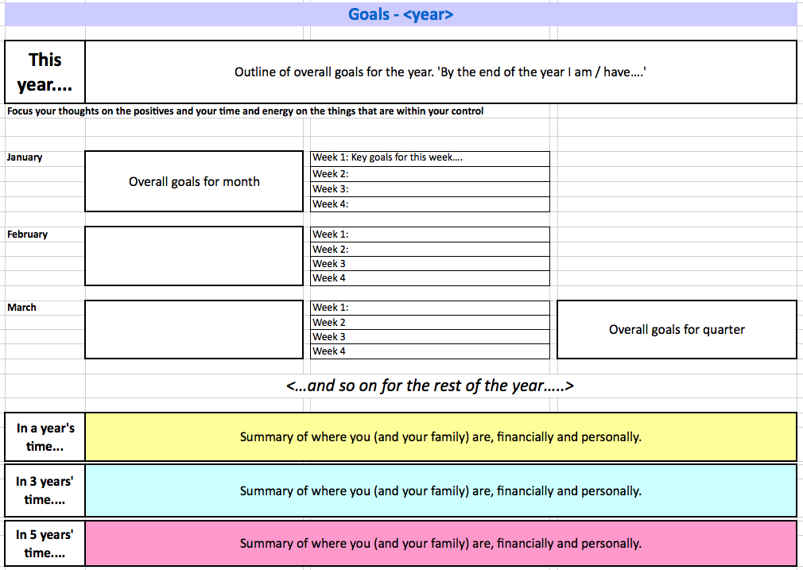
Template available to download.

If you have never set goals before / are not used to working to precise short-term targets, I would recommend you read one or more of the books out there specifically about the subject. Brian Mayne’s ‘Goal Mapping: How To Turn Your Dreams Into Realities’ is one of the market leaders that I have used myself.

